1. Creating and Renaming Files/Directories

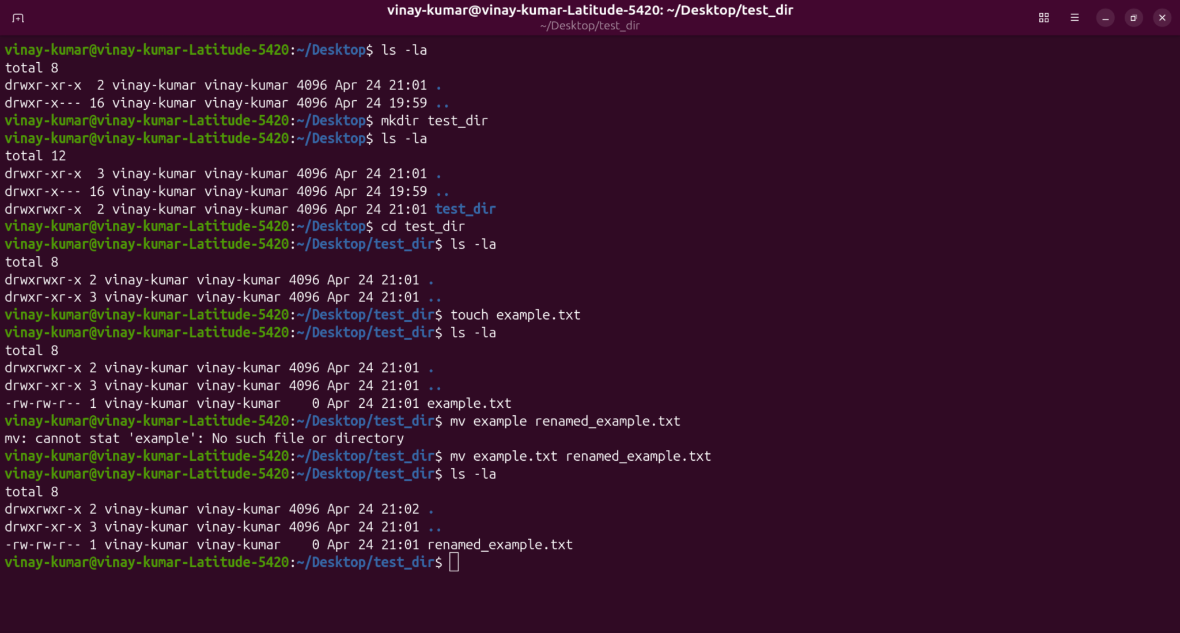

- To create a directory use mkdir directory_name (spaces are not allowed in directory name, it will create seperate directories if we give space in foldername)
- To go to any directory use cd directory_path, for example cd /Desktop/test_dir
- To create a file use touch example.txt
- To rename a file use mv example.txt renamed_example.txt

2. Viewing File Contents
- Used cat to display the contents of /etc/passwd - cat /etc/passwd
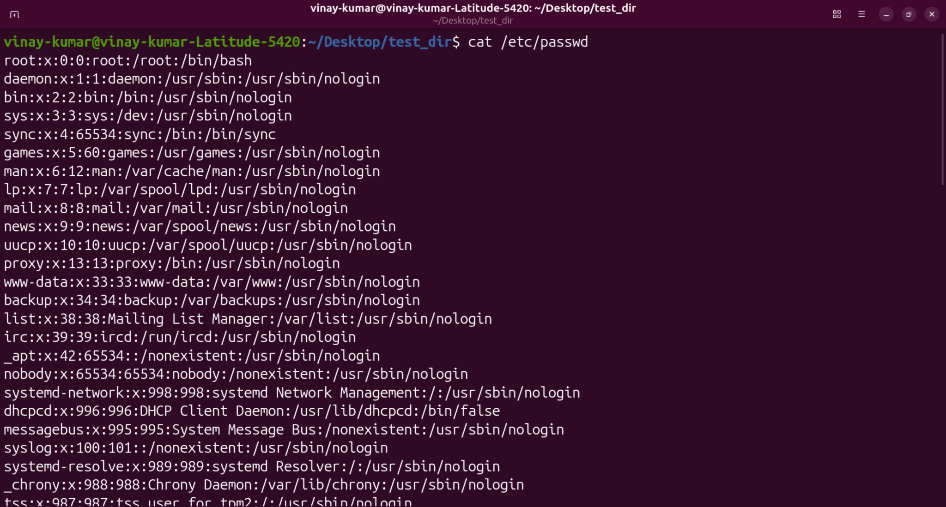
- Display the first 5 lines of /etc/passwd using head - head -n 5 /etc/passwd
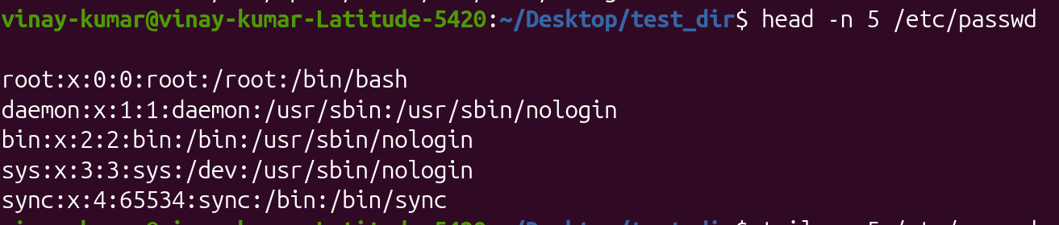
- Display the last 5 lines of /etc/passwd using tail - tail -n 5 /etc/passwd
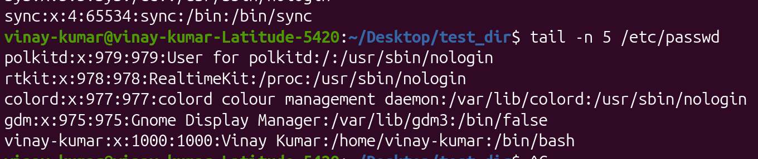

3.Searching for Patterns
Use grep to find all lines containing the word "root" in /etc/passwd.
cat /etc/passwd | grep root - will give all root occurrences.
cat /etc/passwd | grep -n root - will give all root occurrences with line numbers.
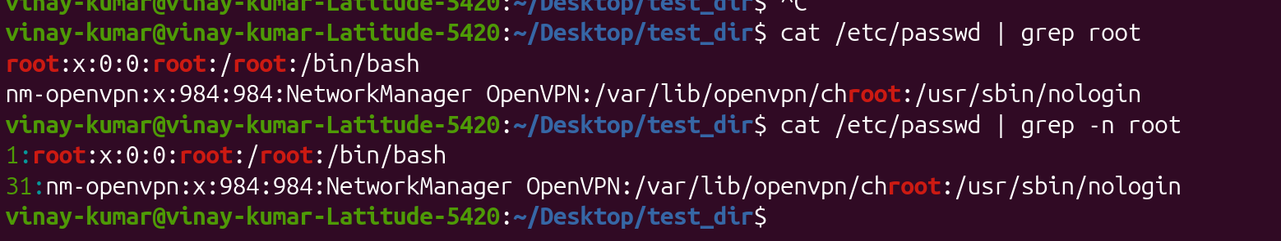

4. Zipping and Unzipping
Compress the test_dir directory into a file named test_dir.zip using zip.
zip -r test_dir.zip test_dir/ (zip -r filename.zip directory_name)
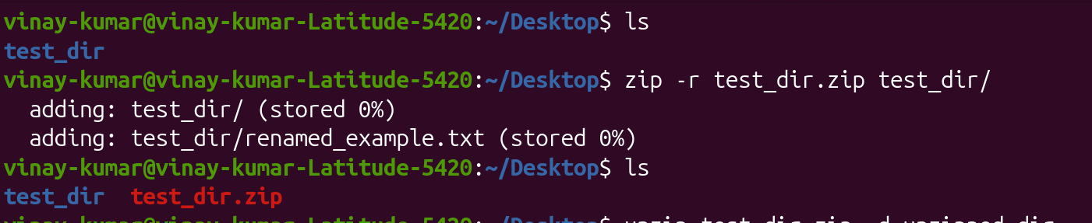

Unzip test_dir.zip into a new directory named unzipped_dir.
unzip test_dir.zip -d unzipped_folder (unzip filename.zip -d directory_to_unzip)
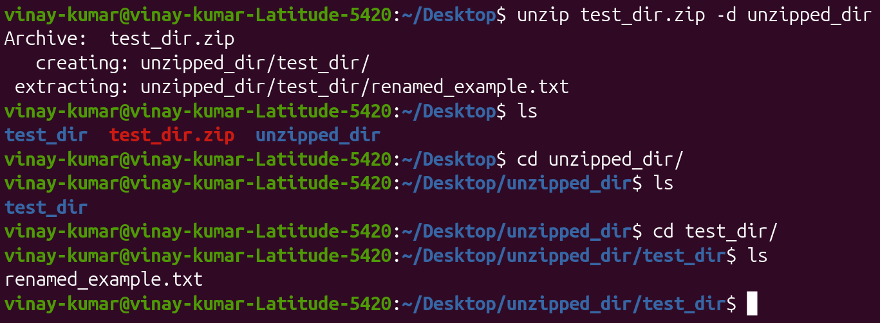

5. Downloading Files
Use wget to download a file from a URL (e.g., https://example.com/sample.txt).
wget https://raw.githubusercontent.com/vinaykumardudikatla-art/linux-assignments/refs/heads/main/example.txt
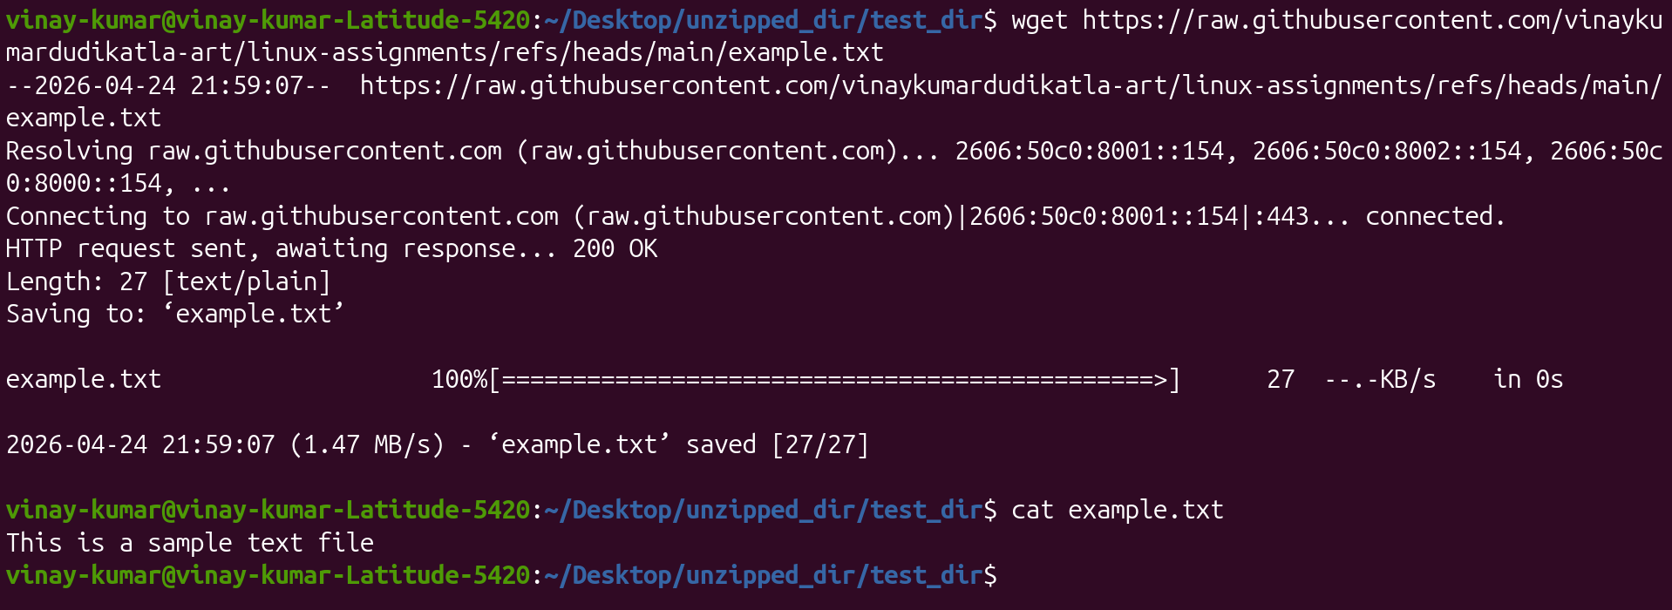

6. Changing Permissions
Create a file named secure.txt and change its permissions to read-only for everyone using chmod.
chmod 444 secure.txt (first 4 owner, second 4 group, third 4 others)
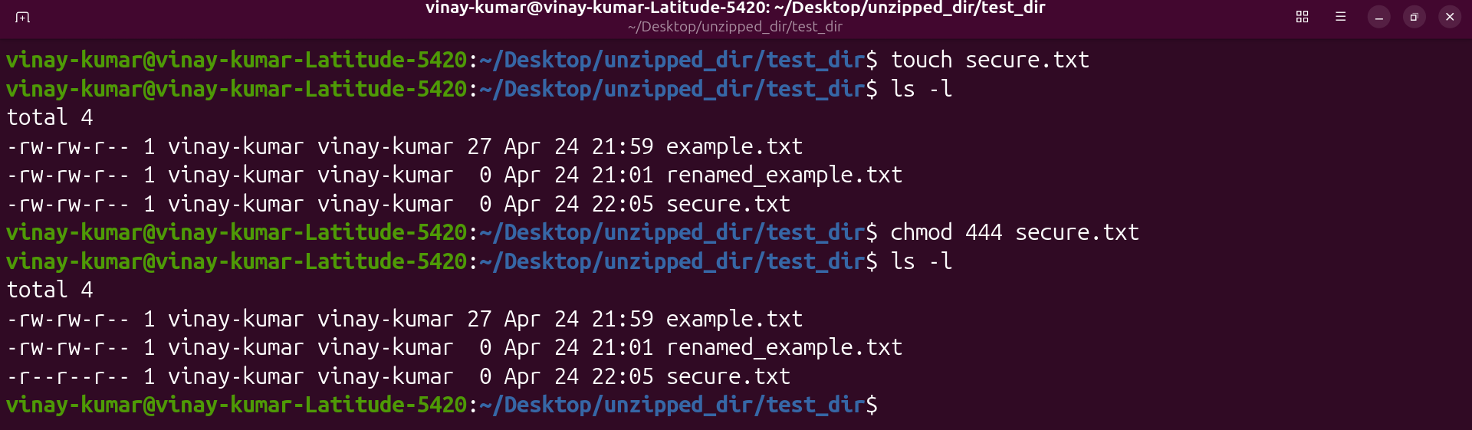

7. Working with Environment Variables
Use export to set a new environment variable called MY_VAR with the value "Hello, Linux!".
export MY_VAR=”Hello, Linux!”
